# ICS 3104

# Lab 2

# Preliminaries

This lab is a continuation of lab 2 part 1 & 2

# PART 3

We add a new control in our form as shown below

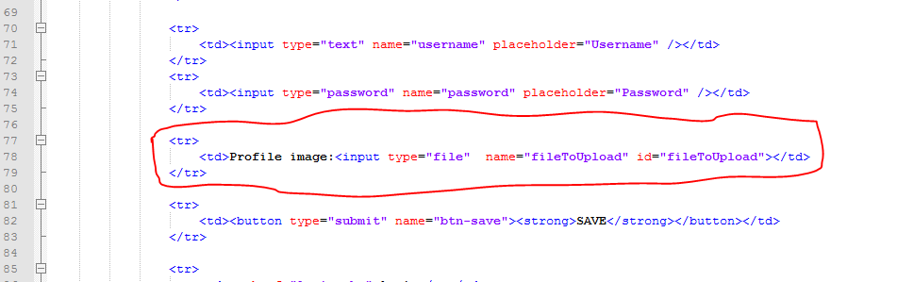

Then we create a class with member variables, getters and setters and methods as shown below. We name our file fileUploader.php

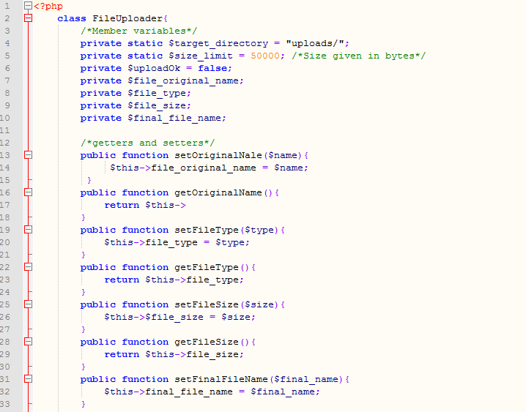

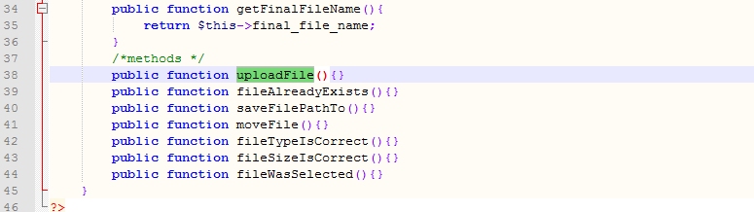

Now create a folder called uploads where your file will be. This is where our file will be.

**N/B:** Do not forget to alter your user table to accommodate the file table

# Your task

Implement the functionality of file upload in the class using the methods that have been provided. If everything goes well return true.

Then the code we have added in lab1.php will be valid as shown below

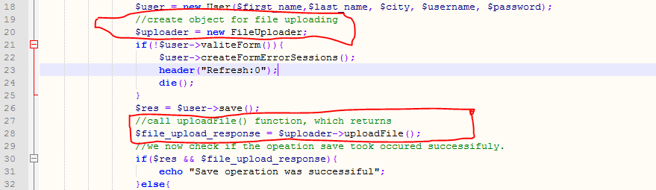

In line 30, we check if both methods return true. If save() returns true and uploadFile() return false, we report a problem, which is of course wrong because user details would have been saved. How would we ensure that we report correctly i.e. if one of the actions is false, we falsify the other one?

**N/B**: you must ensure that the file uploaded is an image type and that does not exceed 50 KBs.

***-This Lab is Complete-***